***Virginia Junior Classical League***

*presents this*

Certificate of Excellence

*to*

Cheyenne Sherwood

*of*

Buffalo Gap High School

*for*

*4th Place in Children's Book*

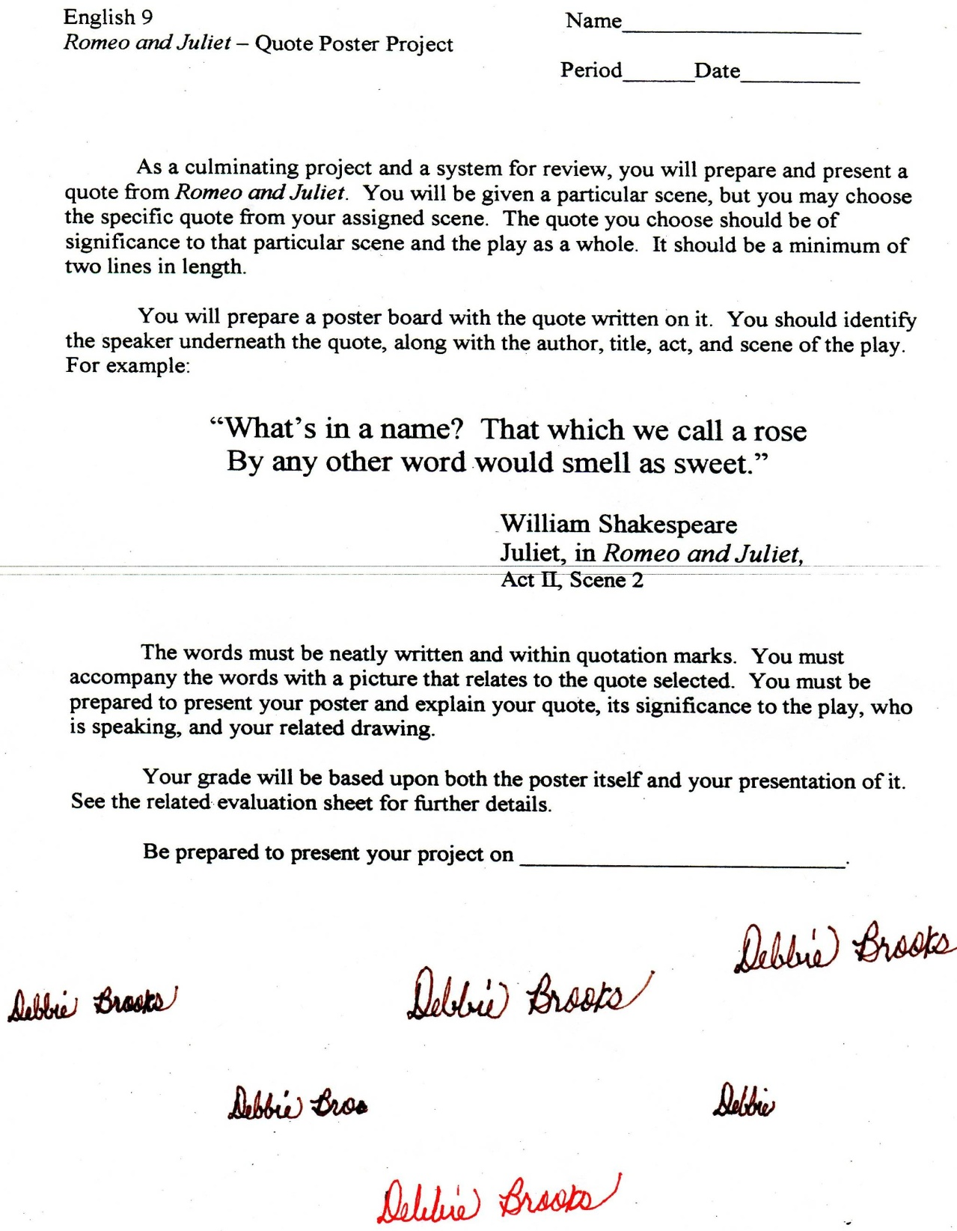

Microsoft Office Signature Line...

*a.d. viii Kal. Dec. MMDCCLXVII A.U.C. 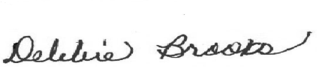*

***Virginia Junior Classical League***

*presents this*

Certificate of Excellence

*to*

Vanessa Clatterbaugh

*of*

Buffalo Gap High School

*for*

*4th Place in Children's Book*

**

Microsoft Office Signature Line...

*a.d. viii Kal. Dec. MMDCCLXVII A.U.C. *

***Virginia Junior Classical League***

*presents this*

Certificate of Excellence

*to*

Katelyn Kennedy

*of*

Buffalo Gap High School

*for*

*4th Place in Ornaments*

**

Microsoft Office Signature Line...

*a.d. viii Kal. Dec. MMDCCLXVII A.U.C. *

***Virginia Junior Classical League***

*presents this*

Certificate of Excellence

*to*

Shellie Bennett

*of*

Buffalo Gap High School

*for*

*4th Place in Pastel*

**

Microsoft Office Signature Line...

*a.d. viii Kal. Dec. MMDCCLXVII A.U.C. *

***Virginia Junior Classical League***

*presents this*

Certificate of Excellence

*to*

Katelyn Kennedy

*of*

Buffalo Gap High School

*for*

*5th Place in Children's Book*

**

Microsoft Office Signature Line...

*a.d. viii Kal. Dec. MMDCCLXVII A.U.C. *

***Virginia Junior Classical League***

*presents this*

Certificate of Excellence

*to*

Katlin Smith

*of*

Buffalo Gap High School

*for*

*5th Place in Watercolor*

**

Microsoft Office Signature Line...

*a.d. viii Kal. Dec. MMDCCLXVII A.U.C. *

***Virginia Junior Classical League***

*presents this*

Certificate of Excellence

*to*

Katlin Smith

*of*

Buffalo Gap High School

*for*

*7th Place in Children's Book*

**

Microsoft Office Signature Line...

*a.d. viii Kal. Dec. MMDCCLXVII A.U.C. *

***Virginia Junior Classical League***

*presents this*

Certificate of Excellence

*to*

Shellie Bennett

*of*

Buffalo Gap High School

*for*

*8th Place in Watercolor*

**

Microsoft Office Signature Line...

*a.d. viii Kal. Dec. MMDCCLXVII A.U.C. *